**A YEARLY ANALYSIS FOR GAMING PRICE**

OVERVIEW

An analysis showing the overall yearly price in gaming stock; the analysis displayed is in 5 years count. The analysis displays the close price average for a cumulative 5-year interval for a 20-year range.

The analysis starts from the year 2002 and ends in 2020 and they are broken down as follows; 2002-2007, 2006-2010, 2009-2014, 2013-2017, 2016-2019.

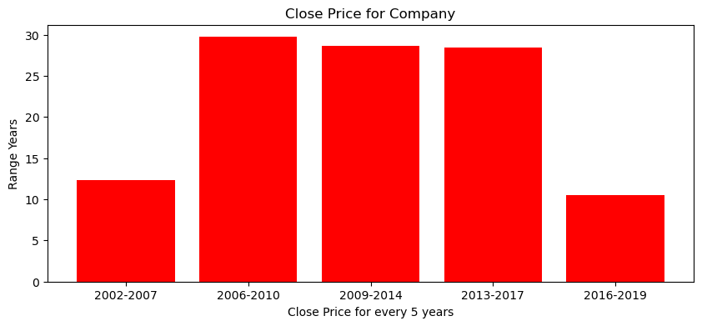As seen from the diagram above, there is an exponential increase in close price from 2002 to 2016. And from 2017, there was a big dip/drop in the closing price. This can be as result of;

* poor marketing
* change of administration
* poor online services
* lack of goods and so on...

**Materials Used**

Python for Programming Language

PostSQL for Database

Matplotlib for Plotting Charts

Pandas for Dataflow

Jupyter Notebook for plotting the chart